Design Patterns and Principles (Mandatory Hands On)
Exercise 1: Implementing the Singleton Pattern
Logger.cs
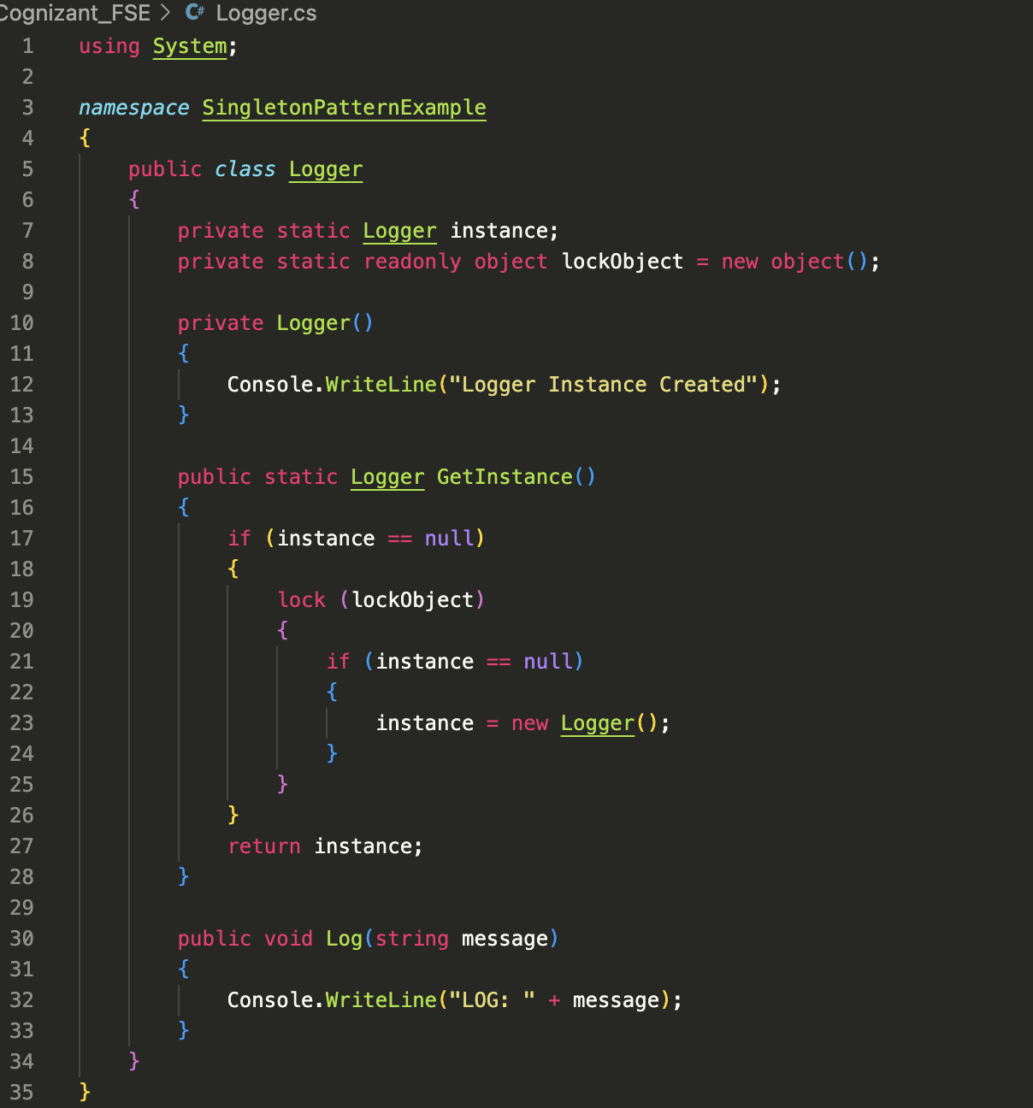
Program.cs
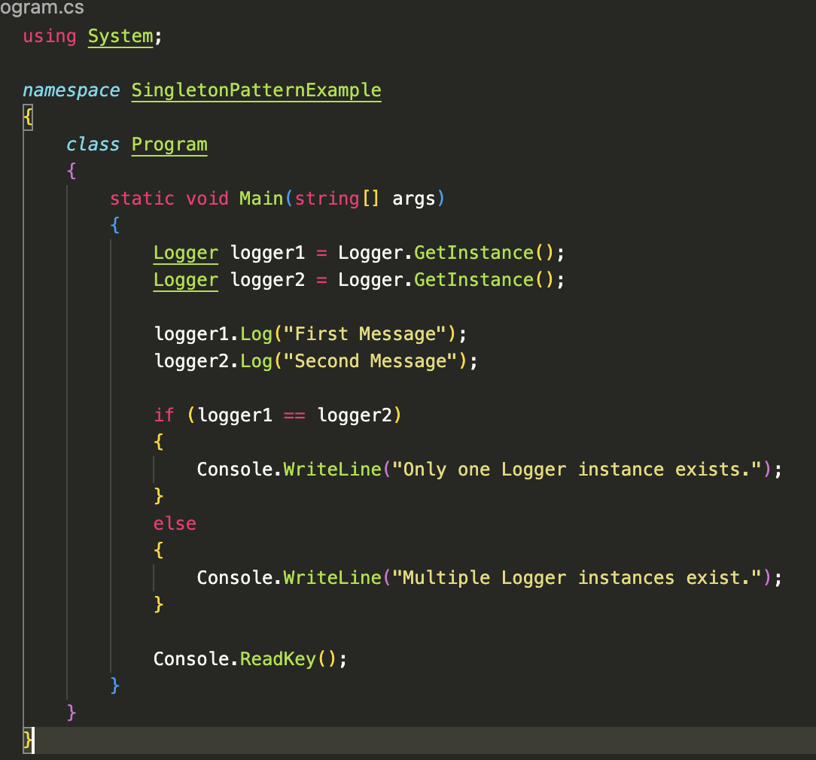
Output:
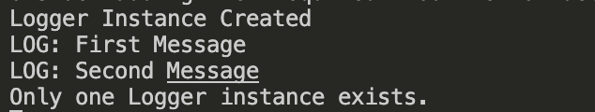

Exercise 2: Implementing the Factory Method Pattern
Document.cs
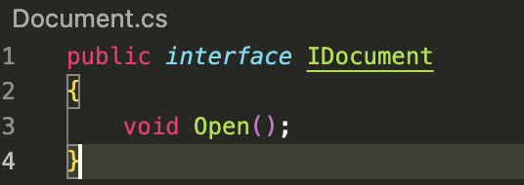
DocumentFactory.cs
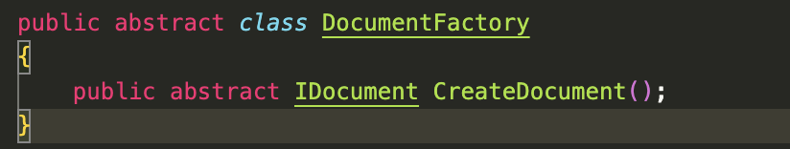
WordDocumnet.cs
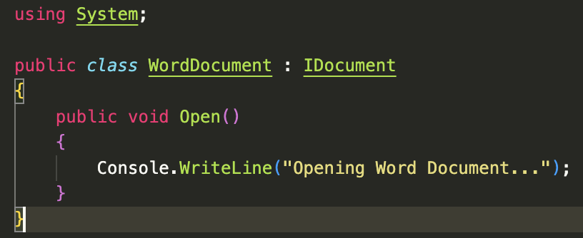
PdfDocument.cs
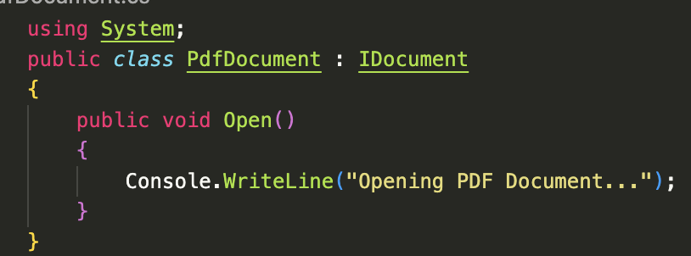
ExcelDocument.cs
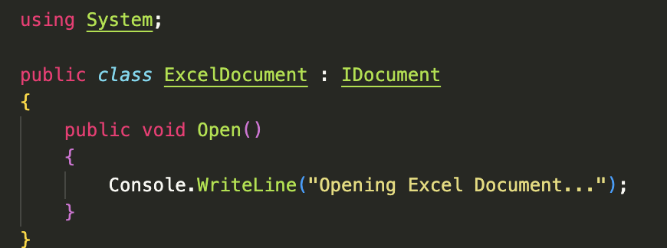
WordDocumentFactory.cs
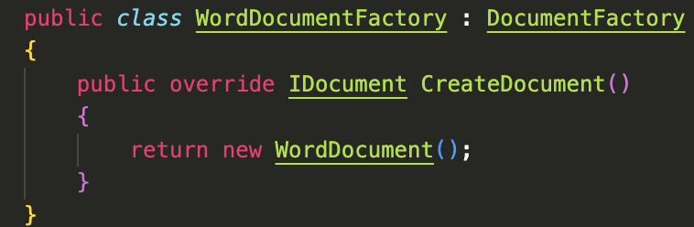
PdfDocumentFactory.cs
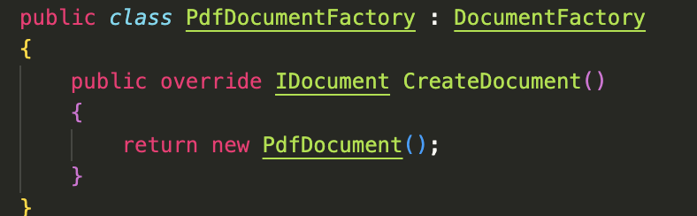
ExcelDocumentFactory.cs
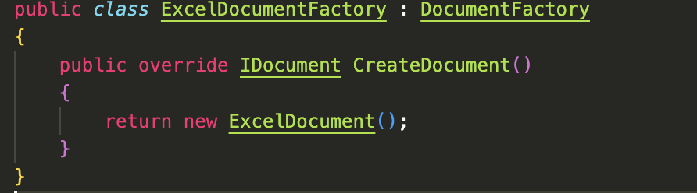
Program.cs
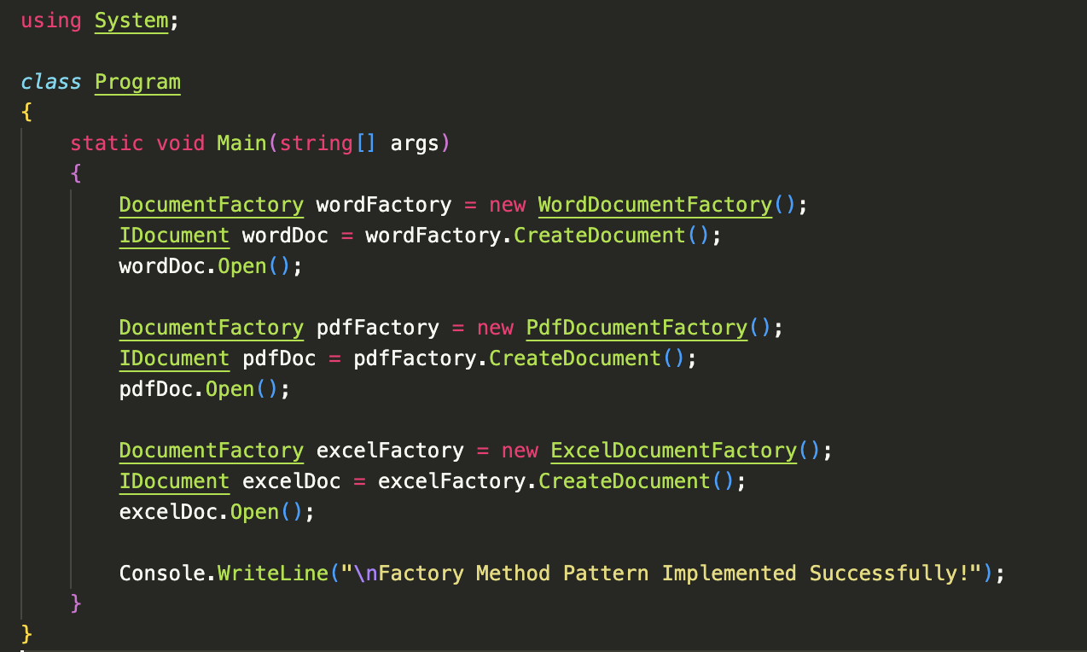
Output:
